Классный час «Bullying Prevention at School»

в 9А классе МАОУ «Средняя общеобразовательная

школа № 165 с углубленным изучением английского языка»

Ново-Савиновского района города Казани

Учитель Мукменева Ильзира Гарифулловна

Форма проведения: классный час-размышление, обсуждение
Цели:
Цель: «Достижение позитивных поведенческих изменений, обмен опытом по предотвращению буллинга»
Задачи:
- Воспитательная:
  - продолжить формирование негативного отношения детей к таким понятиям, как буллинг, насилие, агрессия, и пр;
  - продолжить формирование толерантного отношения к сверстникам и взрослым людям (закрепление понятия толлерантность)
- Образовательная: закрепить понятия буллинг как резко отрицательных явлений жизни, типы насилия
- Развивающая: продолжать развивать такие нравственные качества, как терпимость к людям, доброта, милосердие, сочувствие, сострадание, нетерпимость к любому виду зла и насилия.

I. Организационный момент. Приветствие.
Good morning, dear colleagues.
Good morning children. How are you?
Greet our guests.
Greet your shoulder partners and face partners, sit down.
Today we are going to have a class meeting. I ask you to be active and not to be afraid to speak, express yourselves. I am not going to give you any bad marks and correct your mistakes.

II. Вступление в тему.
Look at the board. I want to start our meeting with this poem.
Table… pupil №… will you read the poem, please.
- What do you think the poem is about?
- How did this poem make you feel?
- How does the author feel?

The topic of our discussion is «Bullying prevention at school».
Bullying is a big and serious problem that affects a lot of kids.
Bullying bothers everyone. It can make school a place of fear, disrespect and can lead to more violence and more stress to everyone.
And now I want us to discuss this problem and find ways of dealing with it. We shall consider this question from different points of view.

III. Вопросо-ответная работа. Использование сингапурской структуры «Placemat Consensus»
You can see three questions on the board. We will do the structure PLACEMAT CONSENSUS.
Tables №1 and 3 you are to answer the first question «What is bullying?». Tables №2 and 4 – the second question is for you «Who is a bully?» and table №5 – your question is the 5th. What types of bullying can you name? Do all types affect children in the same way? Do the words hurt? (Direct, indirect bullying). Think 10 seconds; write your answers in your boxes. Share them in your team and choose the best answer and write it in the middle square. Create your own definition for the word ….
Your time is up. Table… pupil №… read your answer. Good job.
Table 5 pupil №… write down your answer on the board, divide the board into four parts.
I want you to match these words to the types of bullying.
- Have you done any of these things?
- Have any of these things happen to you?
In bullying situation there are a lot of witnesses, bystanders who know and see the bullying happening. There are often more bystanders than those who bully.

IV. Просмотр фильма. Обсуждение.
We are going to watch a film and then we’ll continue our discussion:
1) How did this film make you feel?
2) How does the bullied girl feel?
3) Why do you think she was bullied?
4) Was her mother aware of her daughter’s problems?
And what about the teacher?
5) What would you have done in her position?
6) How does the girl feel now?
7) What did you notice in the background at the end of the film?
V. Развитие навыков монологической речи. Высказывание собственного мнения.
1. Why do bullies act this way?
2. Why do some children become the victims of violence? What are the warning signs of bullying? How do they feel?
Impact of bullying
“Loss of self-esteem, anxiety, stress, depression, difficulties with school work, reluctance to attend school, and, in extreme cases, self-harm and suicide”

3. What should a child do if he/she is bullied?
The first thing you should do is talk to someone .Talk to a friend, family member or someone you know you can trust, and when you talk about the problem you may feel a sense of relief. Even just talking about it can help.
Do speak to officials at school and discuss this problem. The officials can observe and even intervene if necessary.
- What do you think should be done to stop bullying? Who should do the most to stop bullying at school – teachers, parents, school children?
Bystanders are often the key to dealing with bullying, particularly with older children. We know young children will readily tell parents or families about bullying, but not so with older children. In the later primary years and into secondary schooling, bystanders become more important.
Complete the sentenses. Использование сингапурской структуры «Placemat Consensus»
a) If I were bullied, I would…
b) If I were a bystander, I would…
c) If I were a parent of a child who bullies, I would teach him to respect and value difference and diversity, treat others the way you would like to be treated.

d) If I were a parent of a child who is bullied, I would offer support and listen to what a child wants you to do to help, watch out for any signs of change in my child’s behaviour.
e) If I were a teacher, I would…
5. Is bullying a modern phenomenon or did it happen in the past too?
VI. Разрешение проблемных ситуаций. Развитие навыков диалогической речи.
Now, children, I want you to act out bullying situations and find possible solutions to them.
A son has come home in bruises. He says he is OK. He doesn’t want to tell the truth.
You are a father and you are a son. I want you to talk to your son and find out what has happened? And try to help him to solve his problems.
A daughter has come home in tears. She is upset, she doesn’t eat, she doesn’t want to go to school. You are a mother, talk to your daughter, and find out her problems.

What do you think of the advice that mother gave her daughter? Is it useful?
VII. Результаты тестирования (представляет школьный психолог)
Last week, children, you were tested to find out the bullying situation in our class.
I invited our school physiologist to our class meeting. He will present the results of the test. Jaroslav Olegovich is good at English, that’s why he will do in English.

Bullying survey
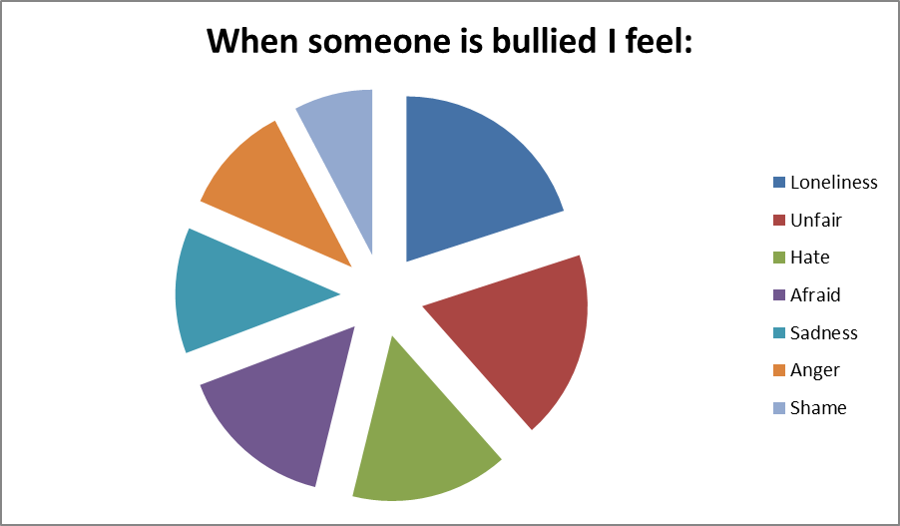

№ |  | true | false
1 | Bullying is a problem in our school | 7 | 12
2 | I have NOT been bullied by someone at our school | 17 | 2
3 | Last year I missed school because I was worried about being bullied | 1 | 18
4 | In our school kids, who are bullied do NOT go to a teacher for help | 15 | 4
5 | There are NO rules against bullying in our school | 6 | 13
6 | If I am bullied, I think one of my classmates will step in and help me | 15 | 4
7 | There is someone at home I ca n talk to if I am bullied | 16 | 3
8 | There are NO adults at school I can talk to if I am bullied | 7 | 12
9 | Teasing and bullying are the same things | 8 | 11
10 | I don’t have many friends at school | 5 | 14
11 | I am afraid of being bullied on my way to school or on my way home | 1 | 18
12 | I know what to do if I am bullied at school | 11 | 8
13 | I do NOT know what to do if I am bullied on the way home | 3 | 16
14 | The adults at my school do NOT ignore bullying | 14 | 5
15 | Most bullying I see is done in fun, not to hurt people | 17 | 2
16 | Most students who get bullied do NOT bring it on themselves | 7 | 12
17 | Bullying helps people by making them stronger | 11 | 8
18 | Teachers who reprimand a student for bullying make it worse | 13 | 6

True/False
- Only boys bully.
- Spreading rumours is a form of bullying.
- Bullying usually occurs in the absence of peers.
- Bullies have more power than their victims.
- Victims should ignore bullying behaviours and learn to fight back.
- Telling on a bully will only make the situation worse.
- Nothing can be done at schools to reduce bullying.
- Parents are usually aware that their children are bullies.

Bullying Survey

First name__________________Last name______________________
Age (yrs)____________ Grade:_________ circle one: Male Female
Look over the following list. Circle four words that you think are MOST TRUE to describe what happens when someone is bullied:
Unfair Cruelty Sadness Yelling
Anger Afraid Bruises Crying
Shame Worry Confident Fleeing
Bravery Hate Fighting Loneliness
Statement True False
1. Bullying is a problem in our school
2. I have NOT been bullied by someone at our school.
3. Last year I missed school because I was worried about being bullied
If you said this is true (D), how many days of school did you miss?
(circle your answer): 1 2-4 5 or more
4. In our school, kids who are bullied do NOT go to a teacher for help.
5. There are NO rules against bullying in our school.
6. If I am bullied, I think one of my classmates will step in and help me.
7. There is someone at home I can talk to if I am bullied.
8. There are NO adults at school I can talk to if I am bullied.
9. Teasing and bullying are the same thing.
10. I don’t have many friends at school.
11. I am afraid of being bullied on my way to school or on my way home.
12. I know what to do if I am bullied at school.
13. I do NOT know what to do if I am bullied on the way home.
14. The adults at my school do NOT ignore bullying .
15. Most bullying I see is done in fun, not to hurt people .
16. Most students who get bullied do NOT bring it on themselves.
17. Bullying helps people by making them tougher.
18. Teachers who reprimand a student for bullying make it worse.

